AIR FORCE NATIONAL PISTOL TEAM NEWS LETTER

30 July 2001

INTERSERVICE 2001

FORT BENNING, GA. The Air Force National Pistol Team attended the 42nd Annual Interservice Pistol Championship at Fort Benning Georgia from 11-14 June 2001. The week long event marked the second gathering of the Air Force National Pistol Team for the 2001 shooting season.

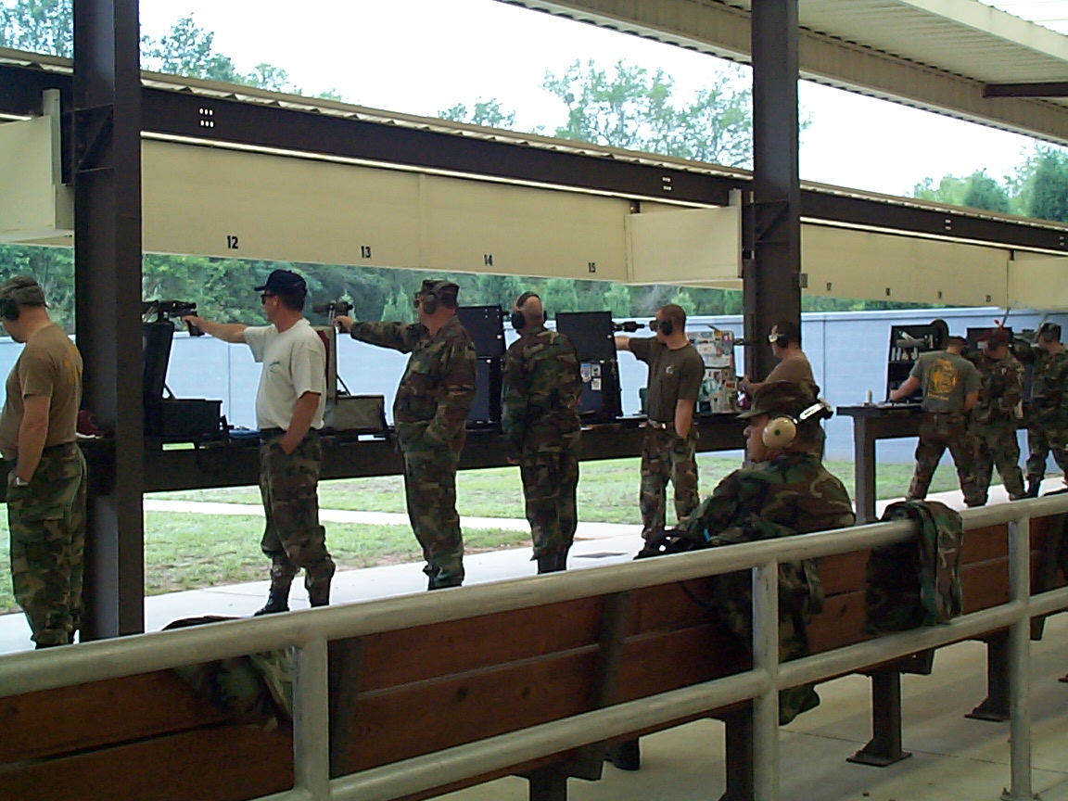
Army Marksmanship Unit Range, Fort Benning, GA

INTERSERVICE 22 CALIBER MATCH
by
Capt Adam Curtis

The 22 caliber match opened up official competitions for the Forty Second Annual Interservice Matches, hosted for the first time by the Army Marksmanship Unit at their Fort Benning, Georgia headquarters. In anticipation of the team’s first day of competition, the Air Force National Pistol Team spent a leisurely evening prior to the competition gathered around the hotel pool, relaxing, smoking cigars and discussing the team’s strategy. One by one, members offered their thoughts, each sharing a short phrase of encouragement or focus to all team members. Two of the most popular thoughts came from 1Lt. Dave Taylor and Major Art Rozier advised “relax” and “just have fun” respectively. SSgt. Jeff O’Conner reminded us to concentrate most on a smooth, continuous trigger pull—especially in timed and rapid fire—and not be overly concerned on perfect sight and target alignment. Although this seems awkward at first, as shots appear to break without a “perfect” picture, this technique allows for a tighter, well-centered shot group. All team members had good advice to share throughout the evening. This pre-competition meeting truly caught the spirit of the impending matches, setting a positive, team-oriented outlook on the upcoming events.

Although the clouds threatened rain, the first day of competition proved to be nearly optimum for shooting--overcast and cool at 75 degrees without wind. As the previous evening’s events unified our thoughts and tied the team together, the next day’s teamwork—and results—reflected the group spirit. The day’s four top scorers in the 22 match tied in points, each scoring 870.
Sgt O’Conner 870-36
Sgt Pollert 870-34
Maj Rozier 870-32
Lt Col Chang 870-29
Individual and Team Match highlights of the 22 caliber match include: Slowfire: Lt Col Chang and Maj Schwartz tied--189-5. National Match: Sgt O’Conner—294-9, Lt. Col. Chang—290-11. Timed Fire: Sgt Pollert—200-12, Sgt O’Conner—199-13.
Rapid Fire: Sgt Pollert—198-8, Capt Curtis—195-7. Blue Eagles: High Score: Major Rozier--290-10, Silver Raptors: High Score: Capt. Curtis—287-9.

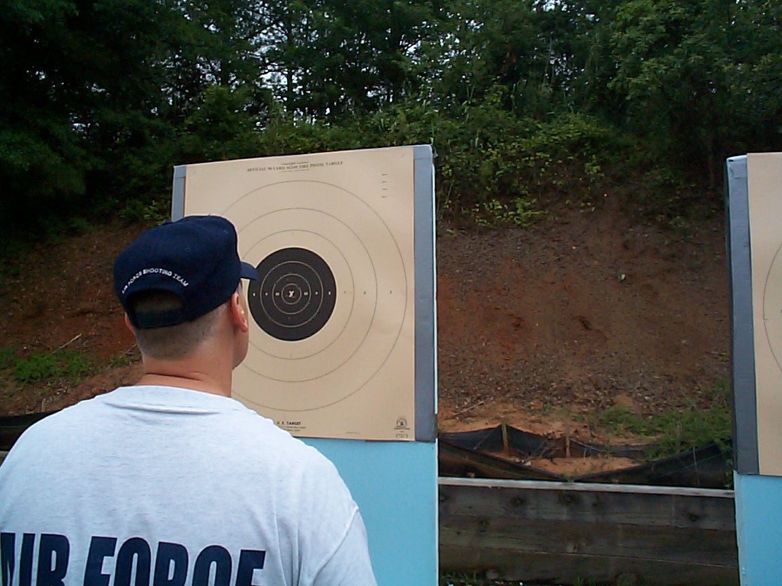
Carefully Studying a Competitors Target

Teamwork and individual concentration marked the team portion of the match. Although there were no alternates available on the Silver Raptors’ team roster, members of the Blue Eagles spotted and helped score and verify targets. Outstanding teamwork! The 22 team match ended just in time—as the last shot was fired the afternoon rainstorms began. Although it was a wet afternoon, the rain did not reflect the positive results by Air Force team members. Nor did it dampen the spirits of an optimistic team for the next day’s matches as we started cleaning weapons and discussing both the past day’s events and preparations for the upcoming centerfire match!

INTERSERVICE CENTERFIRE MATCH
by
MSgt Ricky Hamada

On 12 June 2001, the Air Force National Pistol Team continued striving for victory during the 42nd Annual Interservice Pistol Championship Matches fired on Phillips Range at Fort Benning, Georgia. The centerfire individual match was fired in two relays followed by the centerfire team match. The conditions were soggy, both from the rain that poured throughout the individual matches and the continuous flow of perspiration due to the moderate temperatures and extremely high humidity of the south.

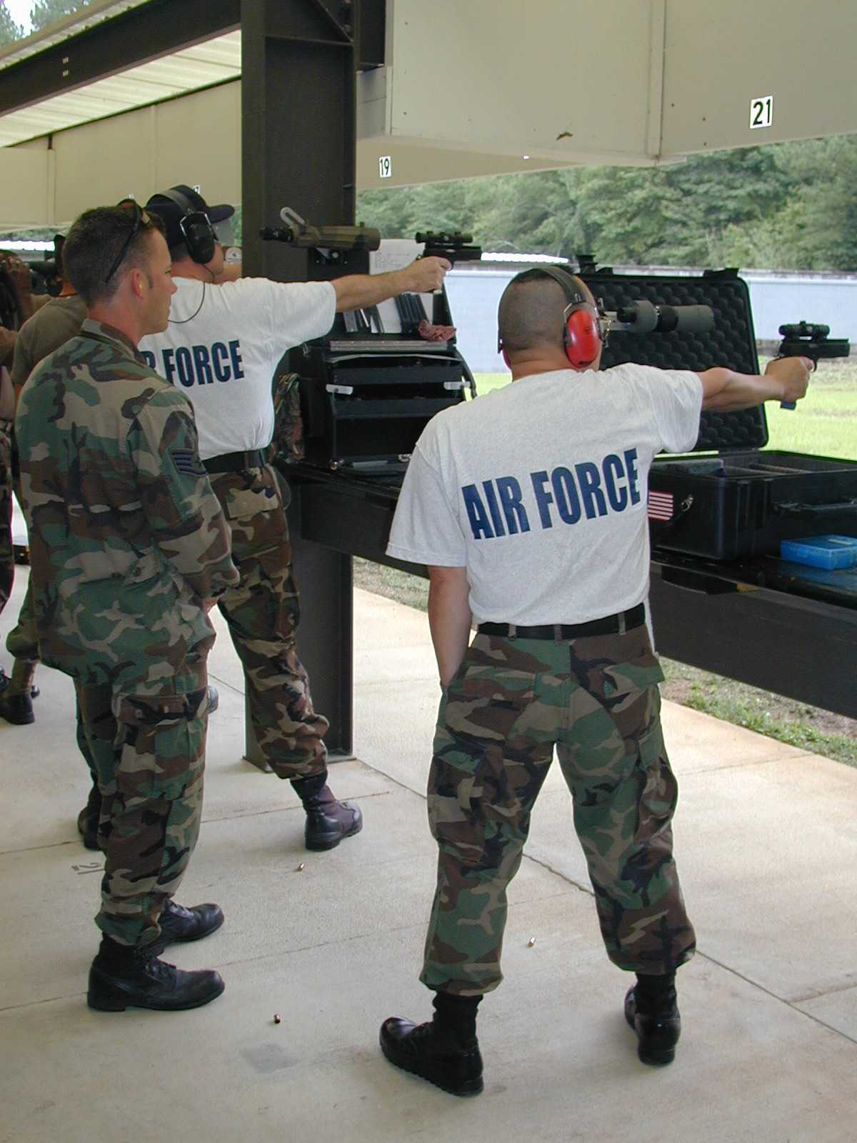
Air Force Silver Members During Centerfire Team Match

Team members searched for ways to work through the difficulties of the Slow Fire stage of the match. Both Lt Col(s) Art Rozier and Maj Steve Swartz (her name was Pat, and I took one for the team) were able to settle into their zones. Each posted a 188. Team members blazed their way through the National Match Course portion with team captain Col(s) Joe Chang leading the pack with a 289-10x. Also successful in finding some balance were our newest TSgt selects John Pollert and Jeff O' Connor. They each came alive during the Timed Fire stage posting 198-8x and 198-9x, respectively. During the Rapid Fire stage, it was Pollert, 197-13x, charging ahead with Swartz, 196-6x, tight on his six. The individual centerfire aggregate scores may not reflect those of the match winner, but they do give light to the fact that each member was able to get into their mental game and transfer the energy necessary to break each shot without giving up.

With the rain clouds quickly disbursing and humidity rising, the team match was about to get underway. First to get into formation was the USAF Eagles Blue Team represented by: Chang, Rozier, Swartz, and Pollert. The Eagles team captain and coach was 1Lt David Taylor. The USAF Silver Raptors Team was quick to assemble as well. The Raptors were represented by: Lt Col Mark Hays, Capt Adam Curtis, MSgt Ricky Hamada, and TSgt Alex Barin. Their team captain and coach was O'Connor. Again, although the scores do not reflect a team championship, both teams were winners. Each team member came away from the firing line to be greeted with a pat on the back, a handshake, a consoling smile, or even just a look. But the meaning behind all of the actions was the same: It's O.K., you put forth your best effort for the team, now put it behind you and get ready to shoot some 45.

INTERSERVICE FOURTY-FIVE MATCH
By
Maj Stephen Swartz

“Beep-Beep-Beep-Beep” the alarm gently chirped me awake at 0545 the morning of “45 Day.” Shuffling off to the shower, I began running my mental preparation checklist. Eyelids- Open. Coffee- Zero Balance. Food- Same. Oh well, take care of those in a few minutes! Roommate- crashed; check later. Weather- hmmm. Morning news says overcast, temps in the 80s, chance of showers. Better check my supply of wet weather gear, to include “scorecard condoms.” Tools- guns clean, ammo prepositioned in one of those nifty Dillon boxes. Attitude- getting there. After an absolutely horrific .22 match, I bounced back for centerfire. Still need to increase my focus and positive reinforcement. While getting the rest of my gear in order, I began visualizing perfect shots and strings. Just enough time for 10 or so dryfire snaps, and then it’s down for breakfast.

The morning “Breakfast Club” looks to be in fine spirits this morning. The usual interpersonal give and take; always for me a high point of team membership. With logistics satisfied (Instant Grits? Abomination!), we mount up and head out for the Field of Battle.

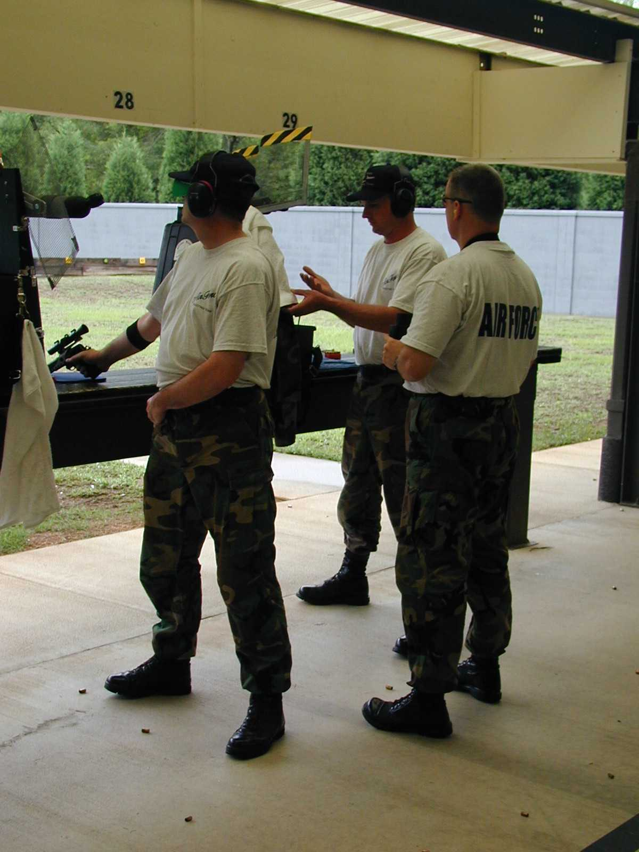

We arrive at the venue (To the strains of Vivaldi? Or was it local drive time pop radio?) in plenty of time to environmentally acclimate the equipment. Weather conditions are pretty much as expected; gray, overcast, mid 70s already . . . “Fitzin ta be a real shirt wringer” as the locals would say. Open the gunbox and check all equipment one more time. Make sure the wet weather gear is handy; also, ops check the polarizing filters in case the clouds break. Load .22 magazines- you do keep your magazines and ammo in your shooting bag so you can load them before the preparation period, don’t you?- and assemble shooting glasses and headgear. And now, the ritual begins: the pre-match stretching, visualization, relaxation, and BS’ing with fellow competitors. And now the adrenaline (epinephrine; actually) spike: “Shooters to the line . . . your three minute preparation period begins NOW!” Yee-Haw! Like a thoroughbred at the gate, my body reacts as if to the starting bell at a Triple Crown event.

Well, sort of. Anyhow, since magazines are loaded and I’m pretty much ready to shoot, I begin dry firing. Check stance and natural POA. Adjust feet, adjust grip as required. Close eyes and simulate a few shots; open eyes and check natural POA again. Final adjustments and then dry fire. Click-Click-Click on a neutral background. Good alignment (dot in tube) and snap (no jerk). Click-Click-Click against the target. Relax. Breath. “For your Slow Fire match, 10 rounds in ten minutes, Load.” Start the clock, check natural POA one last time (yes, it does shift while you are standing there!), insert magazine but don’t rack slide. One or two more snaps, then it’s Showtime!

Or not . . . after successfully averaging 95s or better long line with both guns at local matches, and shooting close to that so far at Benning, it just isn’t working today. I lead off with a pair of 7s. Gun down, shake out, re-establish POA, regrip. A pair of 8s. Felt better; looked better. Think happy thoughts. Finished up the first target with an 88; bounced back for a 91; still struggling. Well, I usually depend on my long line to “cover my mistakes” on the short line. This is not going to work today. What am I doing wrong?

Then it hits me. “D’Oh!” You big dummy! What on earth are you doing, scoping every shot, counting down the score in my head, and trying to shoot a ten on every shot!? What an idiot. O.K., now what? There are still six targets to go; the short line stretches out before me. Take a deep breath. Dial in my sight correction, increase dot intensity, I’m ready to go. Keep the scope in the box. Forget about score. Focus on the behaviors I’m looking for . . . smooth release, concentrate on trigger, keep the trigger moving, establish flow. Timed Fire of the NMC- not entirely successful; I caught myself trying to shoot tens. Bad idea. O.K., readjust- settle-squeeze, settle-squeeze. Focus. Flow. Got out of NMC with a 95 timed, 99 rapid. Rapid is too fast to try to dress it up, this forces me to shoot using the “rhythm method” instead of consciously trying to aim. This is a Good Thing.

By focusing on the behaviors (note to Self: why do I have to keep “rediscovering” this fundamental fact of shooting? Trigger=tens, Dot=not tens) I shoot some of the best short line with the big gun that I have in a while; a pair of 195s timed and rapid. O.K., but will I forget everything over the lunch break? Let’s hope not.

Well, I’d like to say the day ended on a positive note for me; however, the team match was a disaster! As Yogi Berra said once: “90 percent of this game is mental, and the other half is all in your head!” Apparently, I hadn’t established my focus as well as I thought I had. I had some physical issues in slow fire, and made it worse by trying to “time” my trigger release. I ended up with a 284 . . . not a pretty sight. However, in the process I “re-learned” some very important lessons:

- Relax! Tension prevents you from doing your best (whatever that might be on any given day).
- Trigger control is paramount- Jeeze, how many times do I need to figure that out before I accept it?
- Accept your hold (minimum settle) and shoot through.
- No matter how ugly it looks through the scope, the shots will always fall better than expected when you do 1-3 above.
- No matter how pretty it looks through the scope, the shots will always fall much, much, much worse than expected if you don’t do 1-3 above.

Well, it isn’t rocket science, but that doesn’t make it any easier! I had the opportunity to mull over this during the communal team weapons washing and debrief.

Onward to Perry!

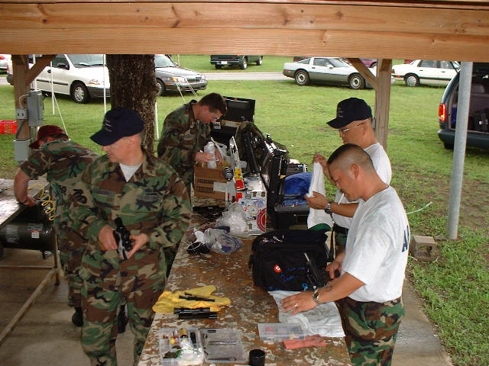
A Clean Gun is a Happy Gun
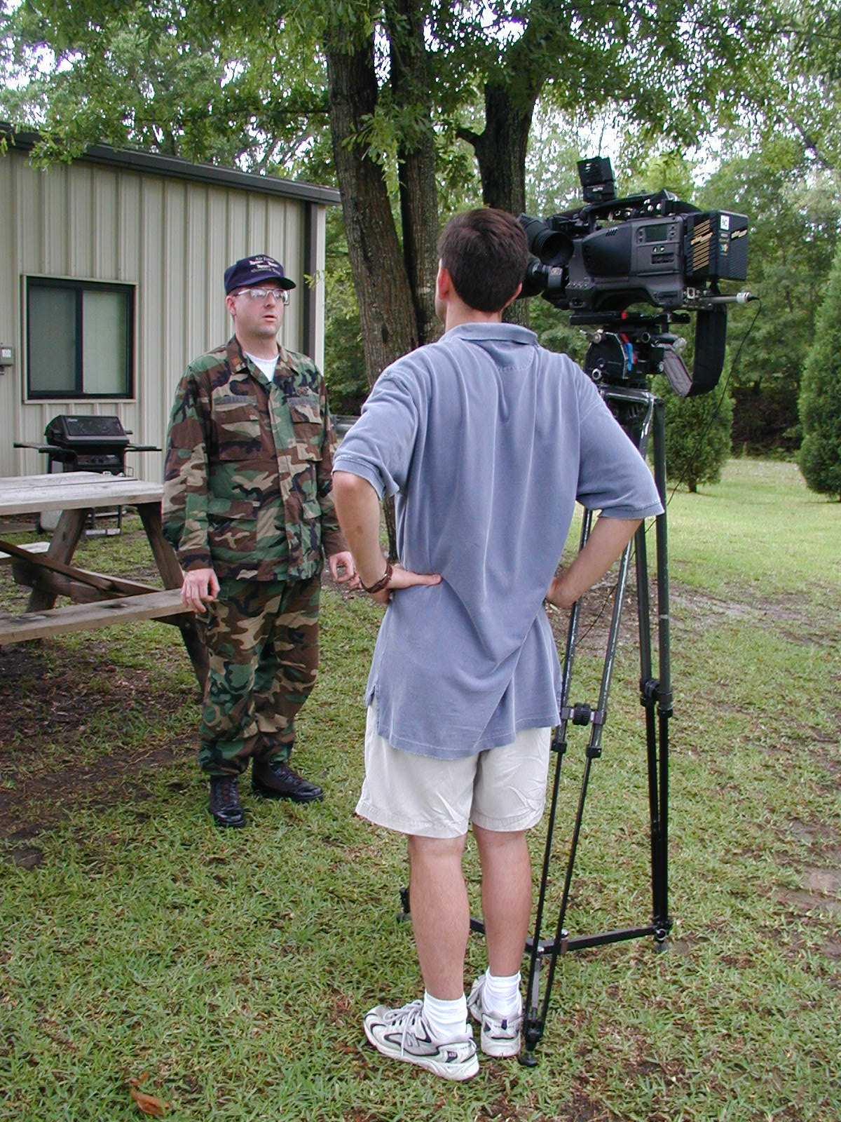
Maj Steve Swartz is interviewed by WTVM Channel 9 News Reporter in Columbus GA. The USAF had 85 percent of the interview on the evening news

The following script was presented by the Col (Ret) Lory Johnson, Jr. who was the distinguished guest speaker during the 42nd Annual Interservice Pistol Banquet.. Col Johnson is a former commander of the U.S. Army Marksmanship Unit (1992-1995). Col Johnson provided the following script to the AFNPT Captain Col (s) Joe Chang.

THE DIFFERENCE BETWEEN GOOD AND GREAT
By
Col (Ret) Lory Johnson, Jr.

COL Hoidahl, distinguished guests, ladies and gentlemen, and especially you competitors. Thanks for giving me the opportunity to be here with you tonight.

A few years back when I worked for the soldiers in the Army Marksmanship Unit I was privileged to attend several Interservice Pistol Championships and the awards banquet that wrapped up each competition. Not only do I not remember who the guest speakers were for the awards banquets, I have absolutely no recollection of what they had to say.

So when they invited me to speak to you, I reminded myself that not a single person would be coming here tonight to hear a speech. Speeches at awards banquets remind me of a story about the Air Force pistol team’s trip to Camp Robinson for an Interservice match a few years back.

Four members of the team were traveling together in a van. One was from Idaho, one from Iowa, one from South Carolina, and one from New York.

After a few hours on the road, the guy from Idaho opens a bag he was carrying and starts throwing potatoes out of the window. The Air Force Sergeant who was from the Air National Guard at McEntire Air Base in South Carolina sees this and asks, ”What in the heck are you doing?” The man from Idaho says, “We have so damned many of these things in my state that I can’t stand it anymore so I am getting rid of some of them.”

In a little while the Iowan opens up a bag and starts throwing ears of corn out the window. The South Carolinian watches this for a bit and asks, “Why are you doing that?”

The Airman from Iowa says, “ We have so many of these in my state that I’m just sick of looking at them.”

Inspired by the guys from Iowa and Idaho, the South Carolinian opens the van door and pushes the New Yorker out.

And that is how I know many of you will relate to this speech. You have heard so many of them that you will toss it out the window before you get back to your motel tonight.

So I asked myself what could a guy who never fired a round in competition say to men and women who are the very best service pistol shots in the United States military.

Well, the title of this speech is “THE DIFFERENCE BETWEEN GOOD AND GREAT.”

Back when I was attempting to serve the soldiers in the AMU, I was fortunate enough to get to see dozens of marksmanship competitions and thousands of competitors all over the world. Whether it was service pistols, service rifles, CISM, one of the Olympic shooting disciplines, or action shooting, I observed that like in every other sport, there are lots of shooters out there who are somewhere on what I call the GOOD spectrum. Now in my book, the GOOD spectrum measures competition performance levels and is different for each shooting sport.

In your particular discipline GOOD probably starts at 2600 and goes out to VERY GOOD being a shooter who shoots a 2650 every once in awhile and who may have actually won Interservice or Perry once in his life.

You can see by that definition that a great many people fit my definition of “GOOD.”

But what makes a shooter “GREAT?”

What makes Bill Blankenship a six time National Champion and a World champion? What lets Hershel Anderson become a National Champion who shot a 2680 in competition? Why was Bonnie Harmon able to win 5 National Championships?

For this speech tonight, I decided to go to some of these GREAT shooters and ask them directly what they thought made them the champions they became. Accordingly, in the last two weeks I talked with seven of the greatest living pistol shooters.

If you will allow me to take liberty with their thoughts and paraphrase their words, the answer turns out to be fairly simple to say.

TO BECOME A GREAT SHOOTER YOU ONLY HAVE TO DO TWO THINGS:

FIRST: LEARN HOW TO SHOOT.

SECOND: LEARN HOW TO BE A CHAMPION

Lets talk about learning how to be a champion first.

Almost without exception these former champions listed as the most important component an INTENSE DESIRE TO EXCEL. They wanted to be the best in the world. They were not satisfied with just being good. They would all set a goal, reach it, then set a higher goal and strive for that. They always wanted to beat their best previous performance not just the other competitors.

Under the category of Desire to Excel, they would also use words such as “Dedication”, “Motivation”, and “Sacrifice”. I asked them if they had any hobbies during the time they were achieving and sustaining their goals. Almost all said no. One said that he had always loved to hunt and fish but gave it up during the years he was learning how to be a champion.

Another said his entire world focused on shooting 2660 or better everytime he opened his gun box and that left him no time for things that took his mind off of shooting.

My own personal observations in trying to determine what separates the GOOD from the GREAT is right in line with what these former champions said about desire to excel. Most of the VERY GOOD shooters I met knew how to shoot, they just did not have the desire to pay the personal taxes associated with being a GREAT champion. They were not willing to devote the time or the intellectual energy requisite to attain and sustain levels of professionalism far above that of ordinary shooters.

Another aspect of learning to be a champion is the willingness to put everything you have on the line each time you compete. If you hold back for fear of losing, you will be able to justify losing by saying to yourself that you really weren’t trying all that hard. That may make you feel better about not winning, but all it really does is make you satisfied with being good instead of great.

The other common theme under the Learn How to be a Champion task was “Work Ethic”. These guys worked hard and diligently at being champions.

So Learning How to be a Champion involves desire, dedication, motivation, sacrifice, and a tremendous work ethic.

And speaking of work leads us to the other difference between GOOD and GREAT-- LEARNING HOW TO SHOOT.

I have seen lists with as many as 40 things that a shooter supposedly must do to shoot well. The great shooters I talked with rolled it all up into just FOUR broad topics. Allow me to list them and then I will talk about each very briefly:

TALENT
MASTERING FUNDAMENTALS
QUALITY PRACTICE
COMPETITION MANAGEMENT

When they talked about TALENT they all assumed that great pistol shooters have some kind of inexplicable gift that most people don’t have. But they could not agree on what that gift is. It seems to be some combination of physical capability, intuition for making a good shot, willingness to sacrifice, motivation, and dedication to learning how to shoot. Whatever it is, it is much more than simple hand to eye coordination and motor skills. I think more than anything else it gets back to the idea of having been blessed with an overwhelming desire to excel. One guy summed it up by saying, “ Lots of people have the natural physical talent to shoot well. Few have the combination of physical skills, self discipline, and personal drive to become a true champion.”

The second of the four keys to learning how to shoot is MASTERING FUNDAMENTALS.

Everyone of the great pistol shooters I spoke with talked about mastering the fundamentals of pistol shooting. Hershel Anderson put it like this, “ Each fundamental must be fine tuned one by one until they are perfected.” Bill Blankenship did not talk with me about “Proper sight alignment.” He emphatically told me about the need for “PERFECT Sight Alignment.” Bonnie Harmon believes that you cannot be great if you are not confident and you cannot be confident if you do not understand exactly how you personally achieve perfection in every single one of the fundamentals.

Another example from Bill Blankenship that emphasizes this point about mastering fundamentals:

You can never be a great pistol shooter if you don’t master the very basic problem of movement. Understanding this, Sgt Maj Blankenship began each shooting season with a month of studying his own personal body movements. He would spend about two weeks on a horizontal line on the target and another two weeks on a vertical line on the target until he understood how his stance, his grip, his trigger pull, his diet, his sleep habits, his physical strength, and anything else affected the movement of his pistol when he brought it up. He wanted to understand why his gun moved and what he had to do with his body, his mind, and his pistol to minimize that movement. That, ladies and gentlemen is mastering fundamentals.

So talent and mastering fundamentals are the first two keys to learning how to shoot. Quality Practice is the third one.

QUALITY PRACTICE is an easy phrase to say but is really hard to do unless you possess that desire to excel we mentioned earlier. Once you get toward the VERY GOOD end of the performance spectrum, quality practice combined with the desire to move into the GREAT category are probably the most important elements in the quest to become a true champion. Everyone I spoke with talked about this in one form or another. It is how they mastered the fundamentals. At every practice session they had a specific fine point they intended to perfect. They were not simply making a pile of brass and hoping they got better by virtue of lots of time on the range.

And finally, all the great shooters I talked with became masters of what I like to call COMPETITION MANAGEMENT. To understand this, remember that while great shooters may enjoy beating the other competitors in a match, they become great champions by understanding that their real competition is with their own shooting ability and their own personal goals, not the scores of other shooters.

Competition management seems to have two major parts:
Discipline of mind and emotion
and a
Shot Delivery System

Mental discipline includes the ability to concentrate. It means that you have taught yourself how to focus. It means that in your mind’s eye you can see what needs to be done to shoot the perfect shot or run the perfect string and that you have the power over your physical body to repeat all those fine points you honed during your quality practices. For example it may mean that you know that for some chemical or biological reason you don’t understand coffee makes you break your shots too early-- so you have sworn off of coffee.

Emotional discipline means that you have done all your competition preparation so well and your confidence in yourself is so high that you are sure you can achieve the match goal you set for yourself. Notice that I did not say that you were going to beat every other competitor. You cannot control what others do so go to the line to achieve your own goal. And don’t fall apart over a bad shot. Recognize why it happened, learn form it, and then leave it! That is emotional discipline.

Having a System For Shot Delivery is nothing more than developing the checklist of what you do before, during, and after each competition. You have spent so much time mastering the fundamentals during quality practices that doing things correctly has become second nature. But the key is that at some point you consciously evaluated every single step in your system and you KNOW why you do everything you do. You may get to the point where you implement your system unconsciously, but if it is something you do, you know why you do it and how it affects your shot delivery.

Understanding how competition management works for you is what allows you to go on automatic pilot on those rare occasions when you find yourself “in the zone”. One former champion told me that when his system was working, he felt at times like he was outside of his body just watching himself shoot perfect shot after perfect shot.

At the risk of oversimplifying a very complex set of interactions, it seems to me that competition management is actually a subset of mastering the fundamentals and quality practice. If you do anything exactly right often enough it almost becomes second nature.

So there you have it! The difference between good and great is a two step process: Learn how to shoot and Learn how to be a champion.

Please note that I did not say it is a “Simple” two step process. It seems to me that of all the shooting sports yours is probably the toughest to master. So for those of you who receive awards tonight I salute you for learning how to shoot and striving to understand the difference between good and great.

Thank You

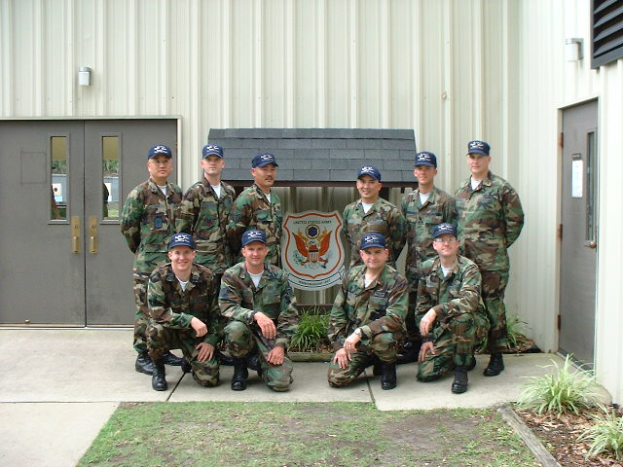
2001 USAF National Pistol Team

2001 NATIONALS
By
Lt Col Mark Hays

CAMP PERRY, OH. Annually, civilians, police, military, youth, aged, handicapped and others make their way to the shores of Lake Erie to continue a tradition that began in the early 1900s—compete nationally against the best marksmen in the country. This year was no different. Young and old from around the nation gathered at Camp Perry from 9-15 July 2001, and the Air Force National Pistol Team (AFNPT) was there in force.

The AFNPT is a unique group of military shooters bound by the love of the sport. Camp Perry is their Mecca. We individually train throughout the year attending matches on our own time while paying for the opportunity to compete mostly from our own pockets. Three of the 12 members had 20 or more matches under their belt this year. A match costs from as little as $25 for a local to as much as $45 for a regional. Each individual on the team owns specialized equipment.

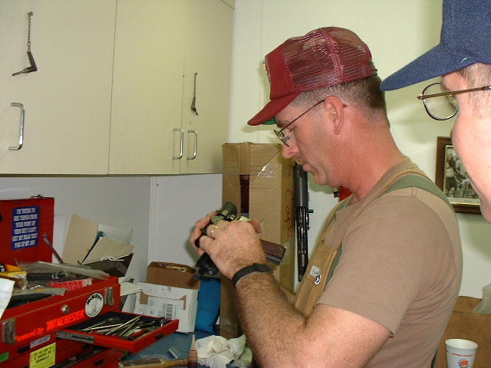
TSgt Dan Norwood Smithing a Team Wadcutter

Team members have not cut corners when it comes to equipment, the Hammerli 208S is the 22 of choice ($1800) and a Curtis, Norwood or Reid Custom built 45 ($1500) are a staple in our boxes. The Air Force generously provides the AFNPT 22s and 45s also funds limited gunsmith support for their maintenance and upkeep. In general, team members use Air Force firearms as back-ups. The team uses its limited Air Force budget to fund ammunition and three team events for the year (Training Camp, Interservice and Camp Perry). If there is enough funds at the end of the year, some of the personally paid matches are refunded (If receipts are kept) but each member does his best to save our precious AF resources.

When the team comes to Camp Perry we arrive with an additional thought in mind—Recruiting. We are the Air Force ambassadors to the shooting world and as such, we spend our off-range time spreading the word to youth and young adult about the Air Force as a career.

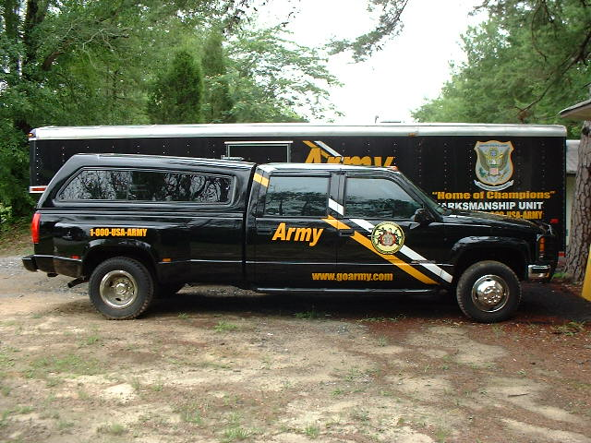
US Army Gunsmith Truck and Trailer

The Air Force National Pistol Team set up an Air Force Recruiting booth on vendors row (unlike Army, Navy and Marine gunsmith trucks) and actively engaged youth with discussions from our diverse backgrounds. Our backgrounds span across electricians, heavy equipment operators, combat arms instructors, munitions, contracting officers, logisticians, engineers, program managers, college professors, recruiters, and the list goes on. Our specialties are diverse and we represent the Air Force proudly.

The AFNPT began the Nationals Pistol week as trainers. The Army Marksmanship Unit annually hosts a two-day event which offers civilians the opportunity to obtain instruction from some of the best military shooters in the world. Training begins with a half day of classroom followed by two relays of practice for each participant enrolled. For most shooters, it’s the only personalized training they will ever get. It’s a great opportunity for the Air Force to represent itself proudly. This year, we trained 5 full relays.
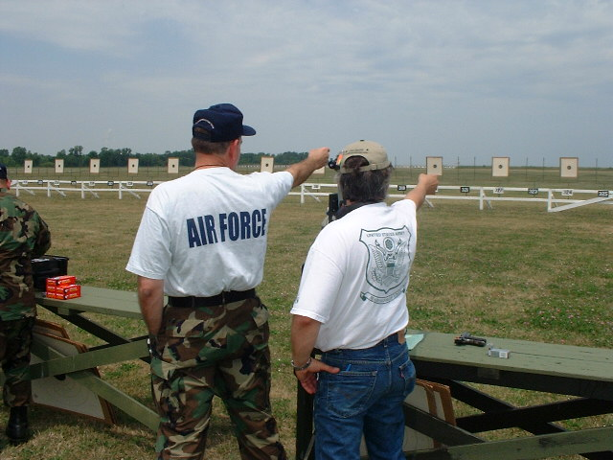

WEATHER. Weather at Camp Perry is part of the experience! Shooting on an uncovered line standing against all of mother natures force has proven to be a challenge in the past. We’ve seen driving rain, high winds, electrical storms, tornadoes, searing heat and combinations of each. When you talk about Camp Perry weather always enters the discussion. We prepare for weather by having rain gear, scope covers made from toothpaste covers, plastic bags to cover our boxes and scoring pads. We even carry the old fashion grease pencils to write on wet paper. We told our newest shooters of the many horrors and to be prepared for the worst scenario much like in the movie the Perfect Storm. Well, prepared they did and an arctic cool front passed through the area that week. Skys clear and a million, temperatures in the mid 70s to low 80s, wind relatively calm. The last day saw temperatures climb into the upper 80s. What a glorious week of weather at Perry. See, you can’t talk about Camp Perry without weather entering into the equation. Maybe next year guys—weather will enter into your Camp Perry vocabulary—guaranteed, we were not making it up.

Nancy Napolski-Johnson fired the first shot during the opening ceremonies this year. Nancy was the winner of Olympic Gold in the 2000 Olympic Games in Sidney, Australia. She won the gold medal on her final shot in Olympic competition, winning the competition by less than a millimeter. After ingraining marksmanship basics into your physical routine, being at your peak mentally is what competitive shooting is all about.

The AFNPT competed strong during the nationals. Many on the team shot personal bests. The Air Force Blue team took a first place while competing in the Master Team category. Team members as individuals won many matches bringing back personal wins for the team.

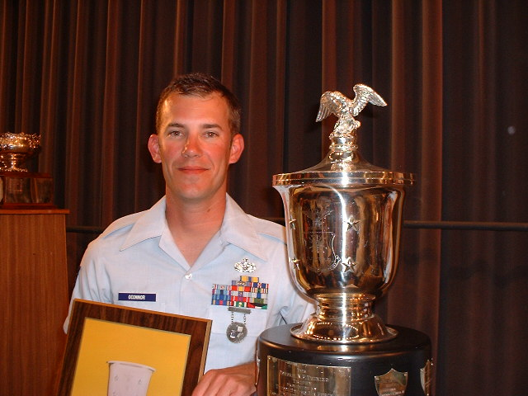

As the team looks toward the Camp Perry experience next year, we look with renewed zeal. Each year provides many opportunities—individually, for the team, and for the Air Force as we all strive to be the absolute best ambassadors we can possibly be representing the United States Air Force at the national level in shooting sports.
