

April 2000 Volume 2 No. 1 2nd Year of Publication

Unofficial Journal of the Air Force National Pistol Team

Memorable Dixie Match Quotes

Lt Col Chang (AFNPT) “Do not let one bullet influence the remainder of the shots”

Sgt Ficke (USAR Team) “What ever score you shoot on a target never cry about it”

Lt Col Chang (AFNPT) “Set your vision and goals as a High Master--Then you will become one”

Sgt Wilson (Army Team): "Coach Arredondo, I don't think we should let the AF Team train at Ft Benning any more, these guys are getting too good"

Sgt Ficke (USAR Team): "Everytime I see your team, you have a new rising star. It's matter of time before all big teams have to deal with your team"

WO4 Watkins (OIC USMCR Team): "I want our team to model after the AF Team. I like the way the AF team continues to develop & improve performance. Your team members continue to jump up in performance another notch everytime I see you. I like the way the AF team gets things done. You handle the business end of team very well. Most of all, your team's effort on recruiting and professional image is right on. You guys even looked better than the Marines at the banquet".

Young Ben Redman: "I can't wait to join the Air Force"

CAUTION: All technical data in this news letter, especially for handloading, reflect the limited experience of individuals using specific tools, products, equipment and components under specific conditions and circumstances not necessarily reported in the article and over which the Air Force Pistol Team has no control. The data have not otherwise been tested or verified by the Air Force National Pistol Team. The Air Force National Pistol Team, its officers and/or non commissioned officers accept no responsibility for the results obtained by persons using such data and disclaim all liability for any consequential injuries or damages.

Air Force National Pistol Team

Primary Team
Lt Col Joe Chang (Team Captain)
Maj David McCormick
SSgt Jeff O’Connor
SSgt John Pollert
Maj Arthur Rozier
Maj Stephen Swartz
SSgt Daniel Bouchee

Developmental Team
Maj Mark Hays
2Lt David Taylor
SSgt Alex Barin
1Lt Adam Curtis
TSgt Ricky Hamada

Inside this issue
Pg
OIC’s Corner 2
Recruiting Spot Light 4
Tyro’s Perspective 5
2000 Dixie Matches 6
2000 Training Camp 8
Hammerli 208s Maintenance 10
Coach’s Corner
Be Your Own Coach Part III 13
Winning 18
Equipment Issue 21

By Lt Col Joe Chang
OIC’s Corner

I would like to express my sincere appreciation to Maj Art Rozier and his wife Sandra for spending their mid-tour Saudi break with the team. Art and Sandra are expecting in May. Maj Rozier truly demonstrated his commitment and the dedication to the team.
Maj Hays planned and organized the overall trip for Ft Benning and Jacksonville Regional. His outstanding organizational skills contributed to the tremendous success.
Ft Benning camp was a huge success due directly to Coach Arrodondo at USAMU. He treated the Air Force as though we were another Army unit and in doing so, he went out of his way to train fellow competitors. I must commend his unselfishness and dedication to the shooting sport. He set a high standard that we should follow concerning our mannerisms and demeanor.
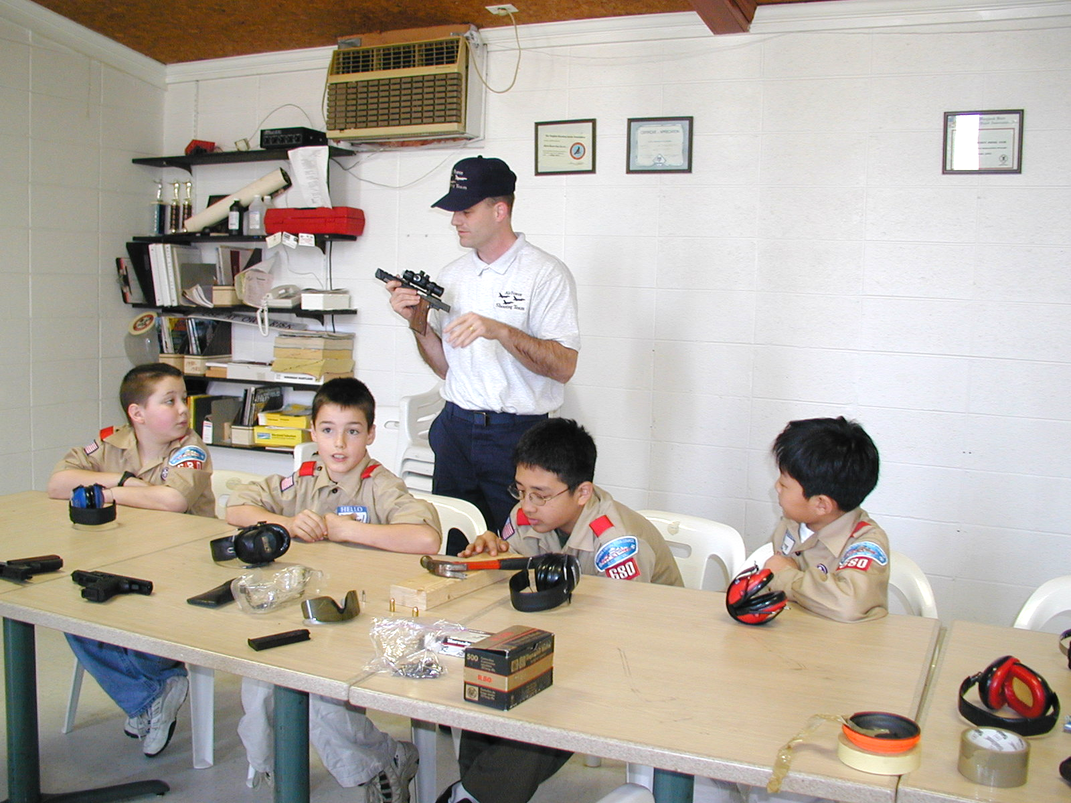
We have two new developmental shooters that will be a valuable addition to the team. They certainly impressed me with their shooting abilities as well as their willingness to make contributions to the team. By the way, we potentially have a female developmental shooter! SSgt Mary Thigpen’s shooting abilities impressed everyone at Ft Benning. When she is ready, I have developmental slot for her on the team.
The quotes listed on page one contained several comments that made years of personal sacrifice to the team worth while. We have come a long way since I joined the team and I ‘m beginning to see excellent progress towards us coming together as a team. There is a swell of master level and above performers on the horizon: Maj McCormick, Maj Rozier, Maj Swartz, SSgt Bouchee, Maj Hays, and Lt Taylor. Others are making equally impressive improvements.
In this issue, Maj McCormick has an article on our recruiting initiatives in Jacksonville Florida. We are paying particular attention across the nation to flying our recruiting flag and wearing our recruiting hat everywhere we go. Look for every future newsletter to contain a spotlight on recruiting. On 25 Mar 2000, we conducted a firearms safety clinic for the Cub Scouts Pack 680 in the Washington DC area. I highly recommend you make the opportunity to do a similar session in your local community. We represent the Air Force and it’s kids like these that represent the Air Force’s future.
Lt Taylor is now responsible for maintaining the team’s performance database. It is your responsibility to get match information to him. You can mail your match bulletin or email your database but you must follow up with a hard copy of your match bulletins.
I want to thank you all for cooperating with SSgt Bouchee in completion of AF Form 1297’s. SSgt Bouchee set a benchmark for an efficient way to take care of team business.

Do everything you can to get ready for Interservice and the National Championship at Camp Perry. We plan to field a team to the Tennessee State Championship in May. Read and heed the lessons included in this issue. Keep up the good work and shoot as many matches as you can.
===============================
Lt Col Chang is a student at the Industrial College of the Armed Forces, Ft. McNair, Washington, DC

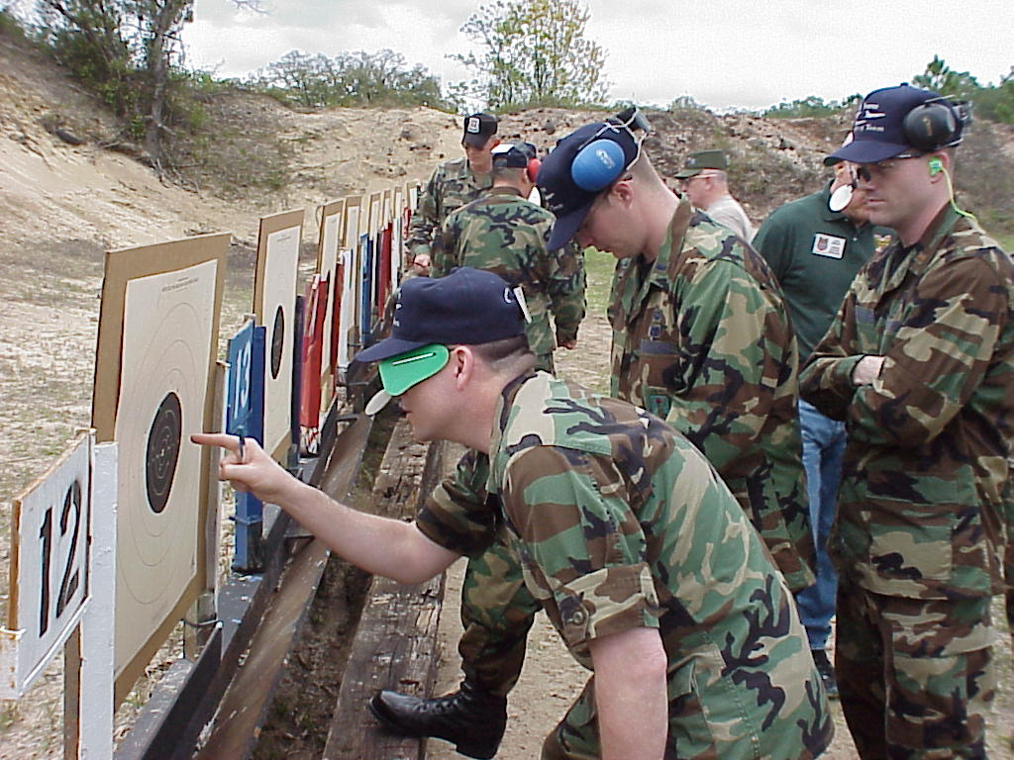

Initiative is defined as seeing what has to be done and commencing a course of action, even in the absence of orders, directions or guidance.

By Maj Dave McCormick
Recruiting Spotlight
AF Team Shows the Flag

The Air Force Pistol Team’s recent visit to Jacksonville, Florida for the Dixie Matches resulted in some very favorable community exposure and positive impressions for our service. Many of the civilian competitors and spectators commented about how sharply dressed the team was and voiced their admiration for the Air Force as a preferred branch of the military. Moreover, they noted how infrequently blue-suit personnel are seen these days in Jacksonville [no base nearby], thereby making it difficult for youth to get information about the Air Force. Our presence, they said, was VERY welcome!

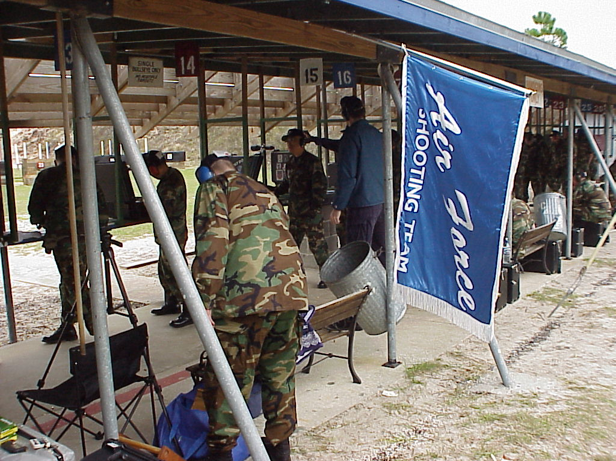

Proudly displaying the Team Flag behind our firing position and wearing neatly pressed BDU uniforms with highly-polished boots and distinctive hats, team members projected a very professional and competitive image. But it seems we were often just as busy interfacing with civilian youth and their families during most non-relay times.

When not on the firing line competing, team members spoke of their personal experiences in the Air Force and distributed current recruiting materials to numerous local youth and parents in attendance at the matches. Of particular interest to many teenagers were the personal testimonials various team members offered about training and education they’d received during their careers. For example, several of the officers discussed how the Air Force had provided full-time attendance and funding for a Master’s Degree (and beyond in Maj Swartz’s case) while an enlisted team member also mentioned the Air Force was the only branch to have its own Community College. These discussions were instrumental in clearing up confusion among many of the youth and their parents; specifically, that Air Force enlistment is an alternative to college, rather than an enabler of higher education. It appears they now understand we highly value education and that tuition assistance and other college-assistance programs are available!

At the awards banquet, nearly 125 other competitors, primarily civilians, mingled with Air Force team members during the evening, sharing experiences, and learning more about our great way of life. Again, there were a number of positive comments about our sharp crisp uniforms and more than a few youth who wistfully commented they planned on joining as soon as possible. Team members encouraged these youth to continue applying themselves academically and contact their local Air Force recruiting office for information on enlistment options. Also, we recommended viewing the Air Force Recruiting Service website at http://www.airforce.com/ for more information.

In summary, team members made a very powerful impression on all those in attendance and certainly persuaded more than a few youth to seek out additional information on the Air Force as a post-high school choice. Kudos to you all.
===============================t Maj McCormick is a student at the Air Command and Staff College, Maxwell AFB Alabama

A Tyro’s Perspective

By TSgt Ricky Hamada

Until the week at Benning, my training regimen was hit and miss. I read the AMU Manual and the good Dr.’s training guide. I tried incorporating the lessons into three local matches in the Sacramento, CA area. Didn't fair too bad, averaging low 750’s for all three. But now, to actually have a coach in front of me, explaining and demonstrating what I need to do, that was awesome. He gave me the necessary fundamentals to go out to the firing line and train. And train I did. Each day we fired a 900, I came out with a new personal best. The drills we did for sustained fire helped me greatly with reaction times for the turning targets. The NOPTEL system provided positive feedback on my hold, trigger and follow through. That alone boosted my confidence. Then on to the Dixie Matches in Jacksonville, going shoulder to shoulder with the big dogs from the other services was icing on the cake for me.

One HM used my shot plan to get himself back in the game. This stuff really works. I told myself to go into it with the same mindset as at Benning, open. I think I succeeded. 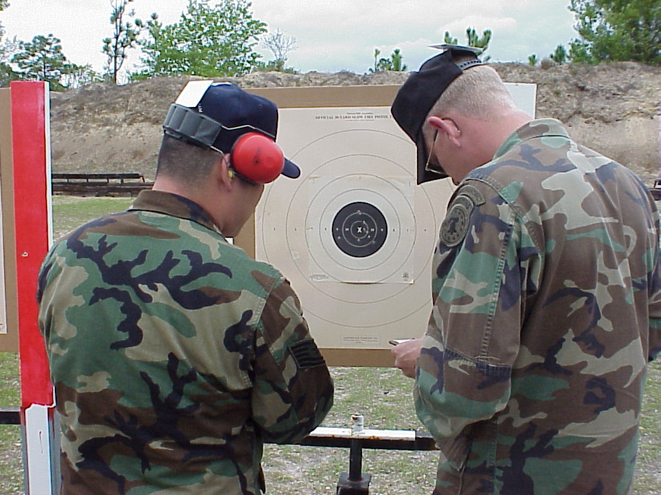 Again, each 900 was an improvement from the previous day. I even put all ten rounds in the 10 ring (of the same target) on Stage 1, Timed Fire. That target got stapled to the inside of my box as soon as we were done with that match. Overall, the best part of the trip was getting to know the team. Each had good inputs for my shot plan development. Things like smooth trigger, gripping the gun consistently, and trusting my hold had a lot to do with my rising scores. How to ensure a team member had a birthday every night was by far the easiest lesson to learn. The team has a great bunch of individuals that can come together as a team and have fun. Thanks for everything.
===========================
TSgt Ricky S. Hamada is a Combat Plans Advisor, Air Force Combat Ammunition
Center (AFCOMAC), 9th Munitions Squadron, Beale AFB, CA

1Lt Curtis Adam: "What you embrace is what you become"-----Embrace positive thoughts….(100-10X)

Feature Article
2000 Dixie Match

By Maj Mark Hays

Jacksonville, FL – On 17 March 2000, the Gateway Rifle and Pistol Club sponsored the “Millennium Dixie Matches”. The three-day event hosted more than 100 accomplished competitors braving high winds, rain, cold temperatures and intense competition. Ten members of the Air Force National Pistol Team represented the Air Force against the best bullseye shooters in the region. By 19 March 2000, the Millennium Dixie Matches determined both the best individual bullseye shooters and teams.

The new millennium continues as a building year for the Air Force National Pistol Team. Maj Art Rosier (M) is still serving his one-year remote to Saudi Arabia as the commander of the 363d Expeditionary Services Squadron. He will end is remote tour in May 2000. SSgt John Pollert (M) and SSgt Jeff O’Connor have both departed for their remote tours to Korea. As the team restructures, we add two new primary members to the ranks, Maj Stephen Swartz (M) and SSgt Dan Bouchee (M). To ensure the team is moving in the right direction, we’ve also added two developmental shooters: 1Lt Adam Curtis and SSgt Ricky Hamada.

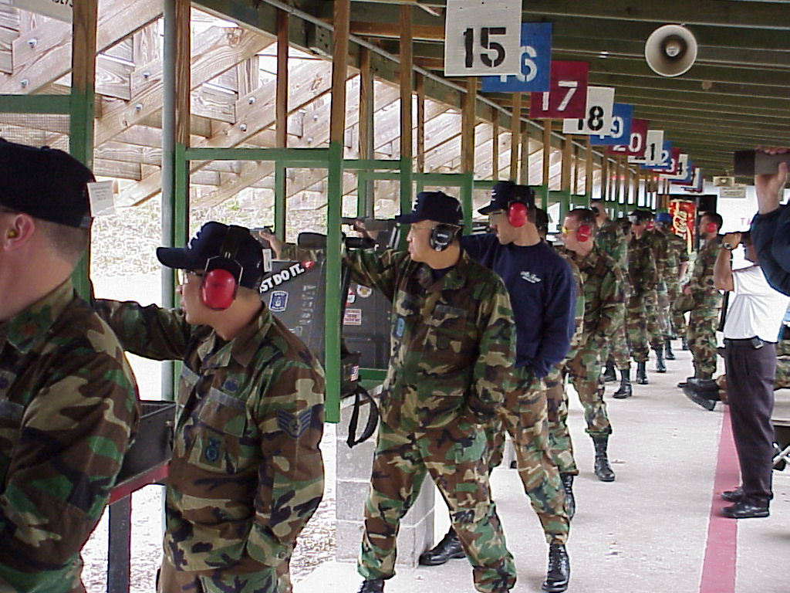

Shooting the Service Pistol

The USAF Eagles Blue Team was represented by: Lt Col Chang, Maj McCormick, Maj Rozier and Maj Swartz. The Eagles team captains were TSgt Hamada and MSgt (Ret) Hall. The USAF Falcons Silver was represented by: SSgt Bouchee, Maj Hays, SSgt Barin, and 2Lt Taylor. The Falcons team captain was 1Lt Curtis.

===============================
Maj Hays is the Director, Air Force Systems Engineering, Office of the Deputy Assistant Secretary of the Air Force (Science, Technology and Engineering), Washington DC

Individual Match Scores

Competitor | Category Ranking | Category  Winning  Score | Individual  Score
Lt Col Chang (HM) | 6 | 2633-106 | 2614-112
Maj Swartz (M) | 6 | 2611-115 | 2562-78
Maj Rozier (M) | 8 | 2611-115 | 2555-71
Maj McCormick (MU) | 8 | 2543-92 | 1679-46
1Lt Curtis (MU) | 9 | 2543-92 | 834-16
SSgt Bouchee (MU) | 3 | 2543-92 | 2537-70
SSgt Barin (E) | 2 | 2563-65 | 2507-48
Maj Hays (E) | 3 | 2563-65 | 2497-59
2Lt Taylor (E) | 6 | 2563-65 | 2480-55
TSgt Hamada (MK) | 10 | 2563-65 | 826-13

Team Match Scores

Highmaster | Total
All Guard Gold | 3503-159
Ultradot | 3503-156
USAMU Blue | 3493-168
USAR Black | 3491-165
All Guard Silver | 3448-130
All Guard Bronze | 3403-96

Master  1st | Total
USAF Eagles Blue | 3418-108
SCNG Blue | 3395-103
USMCR | 3382-091

Expert | Total
Carolina Shooters  2nd | 3399-101
USAF Falcons Silver | 3340-89
Gateway | 3200-66

By SSgt Alejandro Barin
2000 Team Training
USAMU Ft Benning Ga

My personal experience with the millennium spring training for the National Pistol team did not start off smoothly. It seemed like the keyword was LOST. From getting lost at the DC airport while picking up a rental van or lost luggage that contained very important equipment to getting lost trying to get to Phillips range or to and from Ranger Joe’s. It seemed like an almost too common occurrence. Then we met Coach Ray Arrodondo from the US Army Marksmanship Unit. He quickly summarized how he intended to run this training. Just as I had hoped, very little talking and a lot of shooting.

I was very impressed with Coach Arrodondo’s presentation skills. Very professional, down to keeping lecture sessions to about 50 minutes with 10 minute breaks in between sessions. His opening statement of, “Why are you shooting?” made us all reflect at the various reasons why we were here. It really helps every now and then to do a reality check of what motivates us to do what we do. This led to questions of what we intended to accomplish or where we wanted to go. If it sounds like competitive goal setting, then it must be. With the various skill levels we had in the room we proceeded to briefly discuss our individual intentions of pursuing this sport.

Coach Arrodondo quickly continued with a bottom-up review of the fundamentals to execute one shot. He was able to cover all aspects of the fundamentals in a nutshell without being boring. I keyed in on the tips he included like properly fitted shoes with good soles to provide comfort and stability while shooting. He continued with the peculiarity of a good firm grip that allows for good trigger finger placement. As well as aggressive smooth clean trigger control that is continuos and does not stop until the shot is released. Finally, the never ending arc of movement which, believe it or not, is well within the x-ring. Something that we just have to learn to accept and improve through physical conditioning.

We all agreed that all of the elements of a good shot ended right at the shooter’s front sight. All of this was intended to augment shooting drills Coach Arrodondo had planned for us after lunch..

Following a good lunch of barbecue, the coach described how the presence of targets distract us. We began live fire by simulating a slow fire stage without targets downrange. Each shooter was expected to execute a shot just like he or she normally would, i.e., line up the sights and move the trigger until the shot breaks. The drill turned out like the coach had expected with everyone finishing around 5-6 minutes for ten shots.

The next drill involved blank targets at fifty yards with the purpose of repeating the same drill. It took a tremendous amount of discipline to apply what we had just learned, but it paid off. It was exciting to see sub-ten ring groups with some shooters. Too bad we couldn’t play the game this way.

The coach quickly challenged us by putting up regulation targets and calling a slow fire stage. This time the end results were varied. Times ranged from 4 to 9 minutes and some of us had shots that required pasters.

Well, the coach really proved how shooting is a mental game. He also gave us a good look at what we are capable of if we apply ourselves. We ended the day with .22 and .45 900’s to get a baseline performance and zero our equipment.

I was excited and looking forward to the next day. We concluded the evening with a team dinner at a Japanese sushi bar and steak house. It was quite an interesting dinner for some - - especially the flames.

The Army team was there for the next day of training and joined the morning discussion which now focused on the shot plan and some individual questions. It was interesting to note the different amount of information that comprised each individual’s shot plan. Bottom line was that everyone needed something that worked personally. It was also advised that the plan was not permanent and subject to change depending on everyone’s level of experience.

The top shooters of the Army team shared their thoughts on their personal shot plan that included recovery techniques when things don’t work like they should. Dry-fire was dramatically discussed by the coach as something that will benefit shooters only if done correctly. Every effort should be made to recreate what one is trying to remember. Never just mindlessly pull the trigger, that action accomplishes absolutely nothing. Each shooter should have a shot plan that instills confidence and put their trust in. It must be adaptable to meet differing conditions. Finally, the shot plan must have a goal in mind.

The afternoon shooting comprised of short line sustained fire drills and computer and video aids like NOPTEL and heads up video training. The coach briefly discussed the dynamics of getting the first shot off cleanly. He emphasized the importance of the first shot and how it often dictates the process of the succeeding shots. He ingrained the mental confidence of being able to shoot a center shot right off the bat and how much simpler every shot is after that.

We started live fire with one shot drills in two seconds until we progressed to regular timed and rapid fire cadence. We learned patience and persistence in delivering each shot. Patience paid off in nice clean targets every now and then. We concluded the day with a pair of 900’s applying what we had learned.

Coach Arredondo and the Army team had to leave for Jacksonville the next day to conduct training camp. However, we started bright and early with another pair of 900’s. We concluded training midday to get ready for the trek to Jacksonville, FL. This year’s training camp was especially productive for me. I was hoping for some quality trigger time for which I got a lot of. I had the opportunity to try certain things I wanted to work on. Most importantly, I got first hand experience on some good mid-90 long line targets and clean targets at the short line. This gave me the boost of confidence I needed to enter the Jacksonville match. Training at Ft Benning has given me a list things I want to work on both physically and mentally and more importantly, a regenerated hunger to go pull the trigger. I will say that this year’s team training at Ft Benning was a truly productive experience.

===============================
SSgt Alejandro Barin is a Weapons Instructor, Fort Dix, New Jersey

“Shooters from the Army Marksmanship Unit dry fire for an hour every day”

By MSgt (Ret) Edwin Hall
Hammerli 208S Maintenance

During the Dixie Matches held in Florida in March 2000, Mr. Larry Carter of Larry’s Guns spent some time with the Air Force National Pistol Team members discussing the care and cleaning of the Hammerli 208s. He described both basic and detailed cleaning and maintenance as well as adjustments to the trigger. The detailed cleaning/care involves punching out pins and disassembling the internal parts. This should not be done soley from notes, and is only necessary on a semi-annual or annual basis, depending on how much shooting is done. Therefore, detailed notes will not be covered in this document.

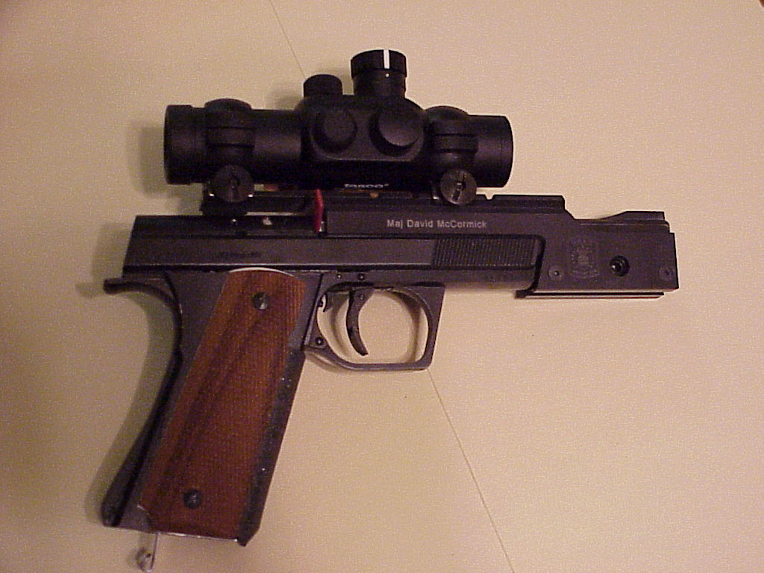

1. Mr. Carter emphasized that NO chemicals or cleaners should be used for any portion of the cleaning of the 208s pistol. He further emphasized that oil must NOT be allowed into the hammer/sear region as this will wash away the special Moly lubrication, which will cause sear wear. The detailed care may be necessary if any contaminants enter the hammer/sear region or if the first stage of the trigger starts feeling as though it drags. Basic cleaning should be done after each match. For cleaning, the materials/lubricants used were:

a. One specially formed brass brush. This brush is used to clean the chamber. It is made by bending a .25 caliber bore brush at a right angle so that the tip length matches the length of an empty .22 case.

b. One M16 style cleaning brush (toothbrush style with smaller brush at end of handle).

c. Cotton swabs to use for cleaning and for lubrication.

d. .22 caliber patches.

e. Cleaning cloth. A mechanic's cloth is recommended.

f. Nylon cord such as weedeater line or similar. This will be used to PULL cleaning patches through the bore. Prepare one end of the cord by melting it so that it clears the bore but will hold on to patches. Form the other end into a point that will easily pierce the .22 caliber patches.

g. CLP type lubricant.

h. Molybdenum (Moly) grease which does NOT contain graphite.

3. Steps involved in cleaning the 208s:

a. Disassemble the pistol far enough to remove the slide.

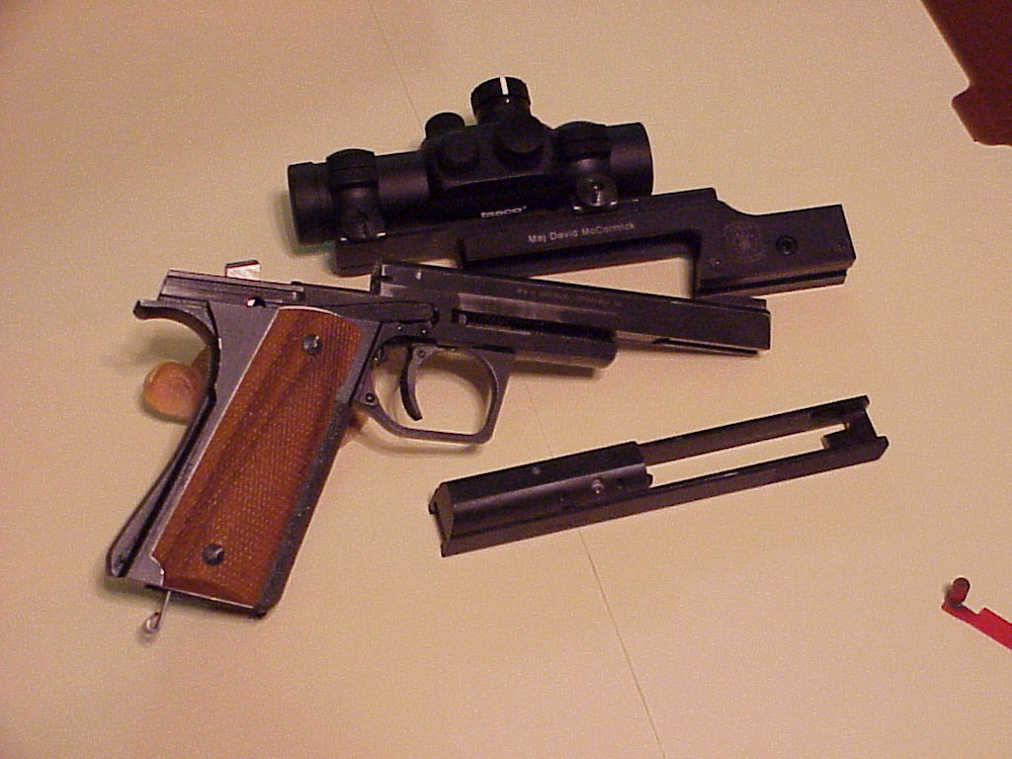

b. Remove the grips.

c. Remove the trigger bar spring and the bar itself. Note that the spring is supposed to be bent to the side. Do NOT attempt to straighten it. Additionally, the curve should be circular. If the spring is flat or the curved area has a flat section on top, replace the spring.

d. If there is a buildup of debris under the ejector, carefully remove the recoil spring by pushing in on the end with a small flat blade screwdriver and turning so that the post clears the slot in the frame. Do NOT point the spring toward your face as you remove it, as it is under pressure and could easily fly out of the frame. After the spring is removed, lift the ejector out of the frame.

e. Clean the frame using the M16 style brush. Be VERY careful not to dislodge or bend the slide stop spring. Use a cloth around the brush for the magazine well. LEAVE the hammer area alone. It should not need cleaning.

f. Clean chamber using cotton swabs first. Next use the specially formed .25 caliber brass brush by inserting it into the chamber and twisting back and forth several times.

g. Place a patch on the nylon cord and pull it through the bore threading the cord from the chamber though to the muzzle. A patch should be sufficient, however if a brush must be used, do the following: Place the empty rod carefully through the bore from muzzle to chamber first. Next screw the brush onto the rod. Finally, PULL the brush through the bore from chamber to muzzle. Repeat patch procedure. NEVER push a brush through the barrel in either direction.

h. If the crown needs cleaning, use the cloth only. Note that if the dirt pattern is clearly visible, it should show close to perfect symmetry.

i. Clean the ejector and recoil spring assembly.

j. Place the ejector into the frame and the spring assembly into its slot. When setting the spring, start with the post pointing toward the barrel, push to just before the slot, turn the post to engage the slot and lock it into place. Note: Wear marks will be visible on the spring. When the wear approaches one-quarter of the diameter of the wire, replace the spring.

k. Dampen a cotton swab with CLP. Paint a light film of oil under the area where the trigger bar will rest.

l. Place a small amount of Moly lube on three places on the trigger bar: the hole which engages the trigger; the post which contacts the slide; and the hook which engages the sear.

m. Place trigger bar in frame and then put spring in place with the ends pointing toward the muzzle. Ensure that the spring is in the slot on the trigger bar, not under the bar.

n. Using an oil-dampened swab, lightly swipe sides of frame and center inside of slide where hammer rides.

o. Place grips on frame.

p. Place slide on frame.

q. Place rear sight on frame. Mr. Carter said that the rear sight should always be placed back on the pistol to prevent the slide from dragging across the hand while firing.

3. Note that NO chemicals were used for any portion of the cleaning and that only a very light application of oil was used. Do NOT over-oil.

4. Mr. Carter also discussed the following trigger adjustments:

a. Initial Slack - The pistol has to have a small amount of initial slack to ensure re-engagement of the disconnector with the sear. To check this slack, with the grips removed, observe the contact point between the disconnector and the sear. Using the screw on the front of the trigger assembly, adjust to obtain a slight movement between the disconnector and the sear when the trigger is moved.

b. Trigger Stop - The trigger must have a slight movement between sear hammer disengagement and the stop. This will prevent the sear from riding on the hammer surface while the hammer falls. If this adjustment is to close, the sear will wear and need to be replaced. To adjust this, turn the allen screw in the frame ahead of the trigger assembly to ensure that the sear does not drag on the hammer as the hammer is rotated through its arc.

c. First Stage Weight - Use the screw behind the trigger to adjust the first stage weight.

d. Trigger Length - The positioning of the trigger will affect the weight and the length of pull. Therefore, adjust the placement before setting the trigger pull. Do NOT over-tighten the locking screw! Minimal force is needed.

e. Second Stage Adjustment - There are two concentric screws to adjust the second stage. The outer screw will adjust roll; in will increase roll and out will decrease roll. Do NOT back completely out. If backed out too far loss of second stage and damage to the sear will result. If the outer screw is to be adjusted, first turn the inner allen screw inward, out of the way. After the outer screw is adjusted, the inner one can be used to set the weight; normally at two pounds.

MSgt Edwin Hall (USAF Retired) is a former member of the AFNPT

A good shotplan consists of four distinct actions:
- Visualize the entire process
- Write the ENTIRE process down
- Incorporate and internalize the plan
- Update regularly and don't be afraid to try new shooting ideas/theories (ie. "sharpen the stone" and incorporate)

Remember repetition is the key, mental training is as important as live fire and…….
VISUALIZE, VISUALIZE, VISUALIZE!
1Lt Adam Curtis

Coach’s Corner

Be Your Own Coach, Part III: Macro Diagonistics
By Major Steve Swartz, Ph.D.

Introduction

In the last two installments, we talked about designing our own training program, and how to build a “matrix” to help us organize our overall training regimen. This matrix included two “Behaviors” (Trigger and Hold) and two “Activities” (Conditioning and Skills). So far, we have talked about establishing a solid foundation of training activities across the broad spectrum of skills required to perform at a basic (and competent) level of proficiency.
However, remember the difference between “practice” and “training?” Practice only helps you maintain a certain level of skill; and maybe develop consistent performance at that level. Training (on the other hand) is designed to bring your level of skill higher than what you currently have. If all you do is develop a program around the basic factors mentioned so far, you will achieve great initial gains. This is a good thing. But these gains will quickly taper off, and your performance will “plateau” quickly if you allow your “training” program to become just a “practice” routine. And it’s worse than that! If your routine does not give you some way to adapt and grow, the time spent on shooting will begin to “lock in” some bad habits that you will spend a lot of time trying to break later on.
So how do we keep an eye on our training program in order to make changes that will stimulate our future skills development? How do we make sure our time spent at home and on the range is being invested in the highest “bang for the buck” activities? Ultimately, how do we make sure our program is a program of “training” and not just “practice?” Diagnostics, my man, Diagnostics!

Diagnostics

“Diagnostics” is a term that refers to the process of observation and analysis required to discover and assess areas in a process that require change in order for a system to achieve higher levels of performance. Say what!? In a nutshell, diagnostics is how you find out what’s wrong; what needs to be fixed . . . or, if nothing’s broken in the first place, what needs to be changed in order to make things better!. For an automobile, diagnostics would be the “troubleshooting” you do to find faults or flaws in the mechanical system of the car. In medicine, diagnostics is the process of taking X-Rays, doing lab work, interviewing the patient, and then analyzing all the results in order to figure out what treatment to prescribe. In shooting, diagnostics may take two forms. The first, most common form is that used to “fix a problem” a shooter may have. The second (rarely used by the individual shooter) form is that used when a shooter might not necessarily be having a “problem” per se but just wants some recommendations for focus on how to improve overall performance.
Since we are talking about how to “be your own coach” and develop a well-designed overall training program, we may want to talk about how to “tweak” the activities in this program. In this installment of “Coach’s Corner” we’ll kick around the second form of diagnostics first- the “macro” approach. In order to get the most benefit from our training time investment, we need a way to analyze just what the heck it is we should be doing or focusing on during any given session! Macro Diagnostics is the key to doing this. In this installment of Coach’s Corner, I’ll talk about two methods of Macro Diagnostics. The first involves setting goals and determining where your performance shortfalls are. The second involves how to analyze your individual skills and behaviors for improvement.

Goals and Shortfalls

In late 1999 I became interested in how individual match performance (the scores for .22 slow fire, .22 NMC, etc.) was broken down for the best shooters achieving various levels of overall 2700 performance. For me personally, my .22 slow fire scores seemed quite high (for my aggregate). Conversely, my .45 scores (particularly in Rapid Fire) seemed quite low. After talking to many shooters, I became curious as to what would be considered “good” scores in each match across the board for any given aggregate score.
Digging back through a pile of match bulletins, I assembled a database of scores from shooters in local and national matches spanning a range of aggregate scores from 2400 to 2650. After performing a series of statistical analyses, several patterns emerged. The main result was this: at any given level of aggregate score, the breakdown of individual match scores for a shooter performing at that aggregate level was fairly uniform and quite predictable. I took the results and developed a formula that would allow me to enter an aggregate score for a 2700 match, and the formula would give me the individual match scores for the typical shooter performing at that aggregate level.
So what? Big deal. Well, for me this was a potentially useful thing. Here I was, shooting (on the average) a 2550 in a match. I wanted to shoot a 2565. By plugging the value of 2565 into the formula, I could get a score for every target in every individual match that the typical 2565 shooter would shoot. Now I could compare the individual scores I was currently shooting against the individual scores I needed to shoot in order to reach my goal of 2565. Of course, this was really “more information than I needed to know” in order to focus my training efforts.
In order to focus my training efforts, all I needed to know was where I had to do the most work- with my .22, CF, or .45 gun . . . and in which specific event, SF, TF, or RF. Here’s a simple table to show you how it works:

2565 | GOALS |  |  | AVERAGE |  |  | SHORTFALL
2565 | SF | TF | RF | SF | TF | RF | SF | TF | RF
.22 | 92 | 98 | 98 | 93 | 96 | 95 | -1 | 2 | 3
CF | 91 | 97 | 95 | 90 | 95 | 94 | 1 | 2 | 1
.45 | 91 | 97 | 96 | 89 | 94 | 92 | 2 | 3 | 4

Looking at the table above, we calculate our “Goals” for each gun and each course of fire using the formula. Remember, this simply gives us what the typical 2565 shooter would do for a match in order to reach that level of overall performance. Next, we go back through our own records and calculate a recent average for matches that would reflect our current level of proficiency. I recommend using either your last three matches or scores no older than about 2-3 months. This way, you are looking at how you are performing now, and not how you used to perform last year or a long time ago. Finally, just subtract your recent average performance from what your goals should be. These numbers represent your shortfall.
Looking again at the example, where should our shooter spend the most amount of training time and effort? Well, .22 slow fire does not seem to be a problem. We are already meeting or exceeding what we need to shoot there in order to reach 2565. As a matter of fact, our slow fire scores overall seem to be pretty close to what we need to be doing. But what about sustained fire? Here, we see areas for improvement- both in timed and rapid, and with all three guns. So what should our training priorities be? My recommendation would be to start doing a lot of timed and rapid fire drills with the .22 first, and then work with the other two guns as soon as you see some improvement. Alternately, if you are shooting the same gun for CF and .45, then you can add these rows together. In that case, the total points lost with the CF/.45 in sustained fire would be quite high (2+1+3+4) and the training effort should start there.
In any case, the principle is the same: compare your current performance to a set of standards. Identify the shortfall between your performance and the standard. Spend the majority of your training effort on the area with the greatest shortfall. This is how we can plan for getting the most performance “bang” for our training time “buck.” A software program (an Excel spreadsheet) has been developed to automatically make the required calculations and is available from the author (included in release 3.0 of the training handbook).
A huge warning is in order here: use the scores as a diagnostic tool! Do NOT ever never never ever use the scores as a management tool during a match (or practice session, for that matter)! For cryin out loud, most tyros obsess about scores way too much in the first place! By giving you the diagnostic, my intent was not akin to handing a bottle of Jack Daniels and the keys to a Trans-Am to a 16 year old boy on a Friday night . . . the last thing in the world a new shooter (or old shooter, for that matter) needs is to start focusing on scores! The purpose of the diagnostic is to identify an area for training emphasis; no more, no less. After performing the analysis, throw all the numbers away!!!! Perform a new analysis every few months or so just to make sure you are still focusing your training effort in the right area. For gosh sake if you use the goals numbers as some kind of “inside the gunbox reminder” to stare at and obsess over during the match, you are doing a bad thing.

Critical Skills Identification and Isolation

Establish goals . . . compare current performance . . . identify shortfalls . . . apply effort to remedy shortfalls. These are the four basic steps of how to apply diagnostics to achieve greater levels of performance. Actually, these are the preliminary steps in any “program of continuous improvement” from PDCA to Kaizen and all that other TQ stuff. But don’t let that stop you! It works!
Anyhow, the same four steps that we applied to our overall performance with the different guns in the different courses of fire can be applied to our individual skills and behaviors (stance, grip, hold, trigger, etc.). About a year ago a 16th Degree Grand High Imperial 2700 Master (16DGHIM) said something quite profound during an informal “Shop Talk” session with the USAF National Pistol Team. A naïve tyro asked a question that went something like this: “how do you work methodically to improve your scores when you are just starting out?” The 15DGHIM thought for a moment; then a brief smile crossed his face. “Son,” he said “you worry about improving your specific shooting behaviors, and the scores will take of themselves. Holes in the right spot on a piece of paper are just an insignificant side effect of doing the right things.” Cha-Ching!!! Much discussion and clarification followed; but the upshot of it all was this: a shooter is performing a series of physical skills. In order to improve performance, the shooter needs to identify and isolate those physical skills, and then work on improving them. If the shooter focuses entirely on executing the requisite skills properly, everything else will fall into place.
Seems as though there are two basic things we need to do to shoot an X: hold on the X and drop the hammer without messing up. Our stance and grip contribute to hold and trigger release. In order to cover all of the critical behaviors, four diagnostic drills were developed:
Stance/Grip. Assume the shooting position against an appropriately sized training target. Begin your shot plan until initial hold is achieved. Close your eyes, then simulate firing three shots through recoil and recovery. Open your eyes and then assess the position of the dot in the tube; and the position of the dot relative to the target. A perfect assessment would be finding the dot in the center of the tube, and wobbling in the black.
Hold. Assume the shooting position against an appropriately sized training target. Begin your shot plan through holding pressure. Hold on the target for ten full seconds. Assess the “best 1 full second” of hold within the ten second period against the size of the scoring rings. A perfect assessment would be 1 full second of X-ring hold at any point within the ten seconds.
Grip Squeeze. Assume the shooting position against a blank or patterned wall. Begin your shot plan through initial settle. “Pump” the (uncocked) trigger up to “greater than release” pressure ten times. Observe the movement of the dot. Assess whether the movement of the dot was affected by the increasing and decreasing pressure against the trigger. A perfect assessment would be to pump the trigger without any movement or influence on the natural wobble of the dot.
Trigger. Assume the shooting position against a blank or patterned wall. Execute the shot plan through the delivery of a dry fire hammer fall with follow through. Assess whether the natural movement of the dot was affected by the squeezing of the trigger and fall of the hammer. Repeat the action ten times. A perfect assessment would be to drop the hammer with no discernible interruption in the natural movement of the dot every time out of the ten times.
In addition to the four basic assessments listed above, there are two additional “synthesizing” or “integrated” assessment drills that should be performed as well. Dry-fire shots should be executed against an appropriately sized training target (slow fire) and an appropriately sized turning (2-second drills) target. For both the slow fire and sustained fire assessments, the shooter is interested in both the stillness of the dot during release . . . and the position of the dot against the scoring rings of the target. In either case, a perfect assessment would be no discernible movement in the dot during hammer fall combined with a hammer fall with the dot in the X ring.
Now what do you do with these four (six) assessment drills? Remember the four step improvement process: set goals, assess performance, identify shortfalls, remedy shortfall areas. What I have done is create a scoring system for the drills. Establish performance goals within each area; for example, under the Stance/Grip area assign 1 point each for the dot being “in the tube,” “aligned horizontally with the target,” and “aligned vertically with the target.” Assign (for example) an additional 2 points each for “centered in the tube” and “on the target.” So a perfect score for any one drill would be (1+1+1+1+2+2) eight points. Run the drill ten times (total possible score 80 points) and keep track of your performance. After conducting this assessment calculate a percentage score; for example, a score of 56 out of 80 for a percentage score of 56/80 or 70%. Similar weighting points have been developed for each assessment area.
The assessments are conducted on a regular basis; weekly perhaps or at least monthly. Shortfalls are identified between the desired performance and the actual performance in each area. Training effort is applied against the foundational matrix (Ch, Sh, Ct, St; see last installment or the training handbook) according to where the greatest improvement is needed. The full assessment table with score-weighted behaviors is available from the author and is also included in release 3.0 of the training manual.

Parting Shots

(so to speak)

Look, you should have gotten a better idea about how to figger out what it is you should be focusing on during your training sessions if you want your overall scores to advance. I hope you got some useful ideas here for how to avoid the “plateau monster” and make continuous progress. From previous discussions, remember the key is to identify the areas you need to work on and then find something that works for you to improve in this area. The Macro Diagnostics help you identify those areas for improvement.
Right now there are two different directions the next installment could go. First, we could continue our discussion of diagnostics and cover “Micro Diagnostics” next. This would involve a process of identifying and correcting actual mistakes in execution of shooting skills. You know, stuff like the USAMU’s “Wheel of Death” and the like. Alternatively, we could blast off in the direction of discussing some of the mental and psychological aspects of the shooting game. Any preference? Let me know! If I don’t hear any overwhelming ground swell of opinion to the contrary, I’d like to cover mental discipline and the shot plan(s).
In the meantime . . .

HOLD HARD-SQUEEZE THROUGH!

===============================Maj Swartz is an Assistant Professor of Logistics Management, Air Force Institute of Technology, Wright-Patterson AFB, OH

Tips on Being a Good Competitor
Team Success Begins with You!

1. Know the program. Before you leave for a match, get a copy of the program and read it thoroughly. Come to the match ready to tell others the order of business. Don’t expect to be told because that puts you behind the power curve the other competitors are on top of.
2. Check your equipment. Develop a checklist of items you need to successfully compete. Include in the list special items that will put your mind at ease if a certain circumstance takes place (e.g. rain implies - raincoat). Check the list the night before you depart.
3. Know the rules. Do you have a copy of the NRA rulebook? Are you familiar with it?

Winning

By 2Lt David Taylor

On 1 April 1999 I met Major Art Rozier and my life will never be the same. I must give him credit. He tried to warn me. Repeatedly, but to no avail. Since then I have been engulfed, encompassed, and elated by the sport of national pistol shooting.

This is an addictive sport. Each time I pick up the pistol my self-control is directly challenged and each time I accept, abeit in varying degrees. Some matches are better than others, but overall I wouldn’t change a thing. With my addiction firmly established my thoughts increasingly turn to experiencing more and more “good matches”. Ah yes, the quest for increased performance has plagued the shooting mind since the invention of gunpowder.

In order to facilitate this drive for better trigger control/sight picture I have done a bit of reading. I came across a book written by Lanny Bassham titled, With Winning in Mind. Lanny Bassham is an Olympic gold medallist and two-time world champion in rifle shooting. Now don’t let the rifle part throw you off course. What he presents in his book is a system of thinking and practicing, without regard for your particular shooting discipline. In addition to the book, there are tapes that elaborate a bit more on selected topics (Col Chang has them), but all necessary information is contained in the 162-page book.

Despite being only 162 pages, With Winning in Mind is not a quick read. There is simply too much information to absorb on the first try. While it remains an easy read, there are principles involved that require some study and thought. Many of the principles can be found in other sources. Yet I have not found these principles combined in such a manner elsewhere. Intertwined with correct principles of shooting is a way of thinking, about competition and about yourself.

Bassham begins his book outlining some of his early failures in sports other than shooting. It seems the only thing that kept him motivated about competing in anything was his love for the Olympics. In fact, Bassham introduces the Olympics as a motivating tool as early as page six. That is, of course, is you missed it on the cover, the title page, the acknowledgements, and the introduction. While this may seem a bit excessive to one not motivated in such a fashion by the Olympics, it does bring about a good point. He knows what motivates him. This then begs the question, “What motivates you?”

The point is made that everyone has within them the ability to win. Yet everyone does not. What makes the difference? Bassham contends, “the only thing that separates the winners from the others is the way they think. Winners are convinced they will finish first. The others hope to finish first.”

How does one expect to finish first? How does one balance the will to win with the actual result of performing at the maximum? Here Bassham presents a mental model for the human mind. The psychological theory presented is threefold. It contains the Conscious Mind, the Subconscious Mind and the Self-Image.

The Conscious Mind is the source of your thoughts and mental pictures. This is where you display the thoughts that your mind conjures up. The Subconscious Mind is the source of your skills and power to perform. When you learn something by repetition this is where it is stored. The Self-Image is what makes you act like you. It is a compilation of your habits and your attitudes. Your performance and your Self-Image are always equal.

Patterned after this model of thinking, Bassham gives ten principles that will enable you to have a mental management system available on demand. The goal of this system is to achieve a Triad State. When this state is achieved “a person is balanced and in harmony.” Each part of the model is equal in size and efficiency, with the person able to perform at their maximum without frustration. With every theory come flaws. Otherwise it wouldn’t be a theory. Still, you don’t need to buy into the whole theory to derive benefits from it. Whether you subscribe to the Triad State, or another such theory, you needn’t stop reading here. The best parts are still to come.

Bassham continues his Mental Management System with a chapter on proper goal setting. Not only does he stress the importance of setting goals, but also how to implement them into our routines. Adhering to the previous pattern of 10 steps, Bassham gives ten steps to effective goal setting. They are as follows:

- Step One – Decide exactly what you want. Here is where you can answer the previous question of, “What motivates you?” Remember to be specific.

- Step Two – Decide when you want it. Time limits on your goals help you formulate a plan to achieve them.

- Step Three – List the pay value. Why do you want this goal? It is important to set a goal that is big enough to be exciting for you. If not, you won’t do anything to change your habits or attitudes.

- Step Four – Determine the obstacles in your way. What must be done in order to achieve what you have set out to do? In order to reach your goals you must change! What needs to be changed?

- Step Five – What is your plan to get your goal? In step four you listed the obstacles in your way. Here you prepare a plan to overcome each obstacle. Now the price you must pay for the goal is clear.

- Step Six – Ask some important questions. First, do I really believe my plan will work? Second, do I really believe I can work the plan? Finally, is the pay-value worth the price you will have to pay for it? If not, you will need to adjust the goal itself, the time limit, or the plan needed to achieve it.

- Step Seven – Schedule your plan. It helps me to write down what I need to do on a calendar. I don’t write everything. Just the important stuff. Like my live-fire practice next Saturday.
- Step Eight – Start now. You’ve got your goal. You’ve identified your obstacles and how to overcome them. You’ve got your plan. Now get to it. Don’t waste another day. Put out high-quality effort consistently and you can achieve anything.

- Step Nine – Never reach a goal without first setting another one. When you’ve reached your goal of, say, Master, there is no reason to put off starting to work on High Master and/or Distinguished Pistol.

- Step Ten – Never, never quit.

So now you have a goal that you are motivated to achieve. What else can you do to increase your ability to achieve this goal? In other words, what else can you do to speed up the process? An excellent way is through reinforcement. Every time we think about something happening, we improve the probability that it will happen. This brings up a point we all can work on. What do we talk about when we get together? It must surely be positive things, so we can keep positive thoughts and images in the forefront of our minds. There are two kinds of reinforcement, in advance (positive prediction) and after the fact (praise). Reinforcement in advance involves giving a compliment in advance of a future action. An example of this would be, “Major Swartz, you are an excellent shooter. You always shoot well in big matches. In fact, you shoot the very best when representing the Air Force in a team competition. I am very glad you are on the team.” When positive prediction is used the sender feels good just giving the compliment. The receiver gets a wonderful lift, and everyone benefits from the positive reinforcement. Praise works much the same way and can be as simple as congratulating someone on a job well done. Remember if it is a good thing, feast on it. If it is not, then forget it.

Mental rehearsal is another tool to enable a speedy realization of your goals. Mental rehearsal is simply practicing in your mind for the real thing. It has many benefits. One, it is free. Two, the mind cannot distinguish between mental rehearsal and the real thing. Three, you can visualize shooting much better than you are currently shooting. How does a perfect practice sound? Do you think a perfect practice would increase your belief that you can perform at higher levels than you are currently? The answer is a resounding yes! It can also reduce stress involved with a match. Along with actual experience, visualization will compound your mental exposure to matches, allowing you to better channel the increased arousal involved with actual matches in a positive way. While mental rehearsal cannot take the place of physical practice, it is an effective supplement.

There are many other topics covered in this work With Winning in Mind. I feel this article has not done justice to this work, but hopefully has increased your awareness of the written guidance available on shooting. I recommend this work to those wanting to strongly establish or strengthen their mental game. It is available in paperback for $12.95, unless you are lucky and get it from your “secret shooting Santa” at Perry next year (thanks again, Dan). Please utilize the tools presented here along with others you already have, to improve your percentage of “good matches” out on the range. If you are just starting, like me, or are trying to improve on your personal best of 2658, work smart, be consistent, and your life will never be the same.

2Lt David Taylor is the Squadron Section Commander, 1st Operations Support Squadron, Langley AFB, VA

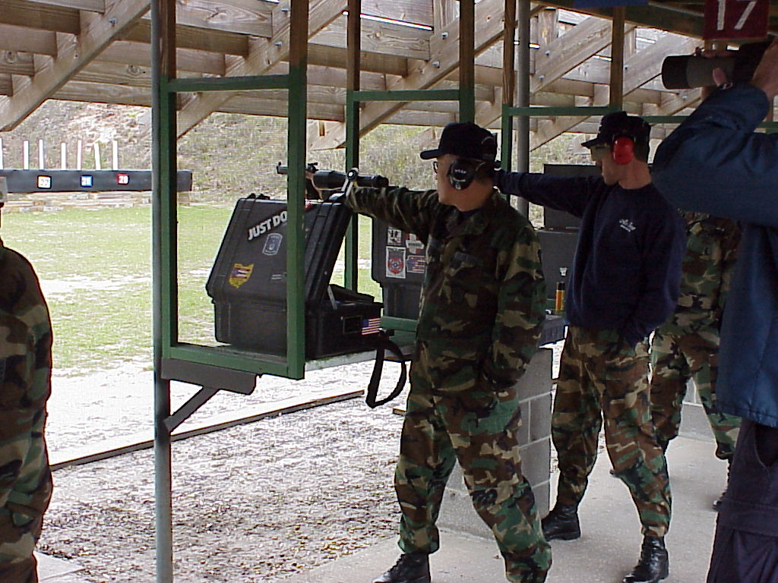

Equipment Issue

Jacksonville, Fl --The new millennium brought with it many team changes, especially team membership. To ensure the team maintained a disciplined approach to USAF issue equipment, we once again accomplished our annual equipment inventory.

Primary .22 most shooters have Hammerli’s, those who don’t plan on purchasing them.
Back up .22s are AF issue Smith and Wesson Model 41s.

Primary wad guns vary from shooter to shooter some Curtis customs, some AF issue guns, a couple Mitch Reed guns and one Les Bear gun.

Service Pistol is an interesting change. Many of the team members now have accurized 9mm Beretta’s. However there are those who still shoot the USAF issue 45.

This looks to be an impressive year. The attitudes are good on the team and we are all focused on our goals and recruiting mission within the Air Force.

- Feature Article: Interservice Matches

Be Your Own Coach: Part 4

- Tech Topics: Reloading

- Hot Weather Shooting

